**DAILY ONLINE ACTIVITIES SUMMARY**

|  |  |  |  |  |  |  |  |  |
| --- | --- | --- | --- | --- | --- | --- | --- | --- |
| **Date:** | **23-05-2020** | | | | | **Name:** | **Ashwini** | |
| **Sem & Sec** | **A** | | | | | **USN:** | **4AL17CS017** | |
| **Online Test Summary** | | | | | | | | |
| **Subject** | | **Python.** | | | | | | |
| **Max. Marks** | | **30** | | **Score** | | | **17** | |
| **Certification Course Summary** | | | | | | | | |
| **Course** | **INTRODUCTION TO FRONT END DEVELOPMENT CSS** | | | | | | | |
| **Certificate Provider** | | | Greatlearning  Academy | | **Duration** | | | 5hours |
| **Coding Challenges** | | | | | | | | |
| **Problem Statement:**  1.Write a C Program to Generate First N Triangular Numbers (Where N is read from the Keyboard) | | | | | | | | |
| **Status: Done** | | | | | | | | |
| **Uploaded the report in Github** | | | | | **YES** | | | |
| **If yes Repository name** | | | | | <https://github.com/ashwiniachar/online-report> | | | |
| **Uploaded the report in slack** | | | | | **YES** | | | |

Online Test Details:

Subject:-Python.

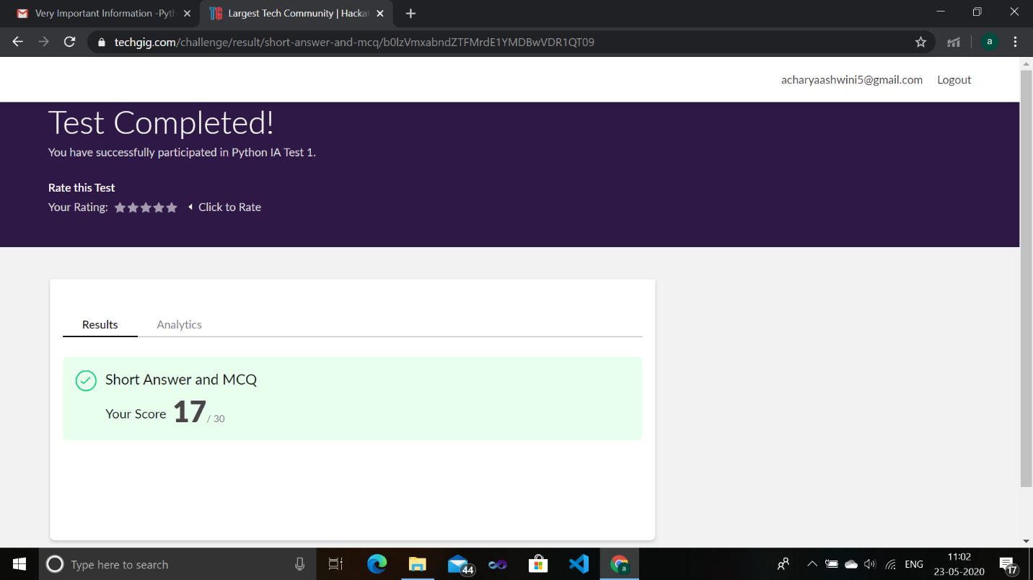

Certification Course Details:

**Introduction to Front End Development css:**

Today I have studied **Pseudo class selector:**

Under this topic I have studied:-

* how to style the page using pseudo class selector

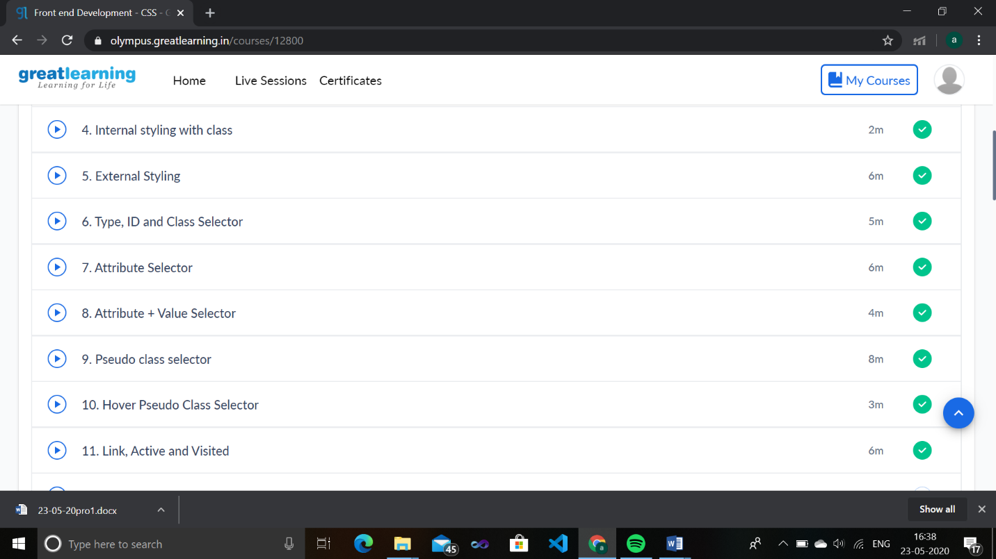Coding Challenges Details:

1.Write a C Program to Generate First N Triangular Numbers (Where N is read from the Keyboard)

#include <stdio.h>

void triangular_series(int n)

{

int i, j = 1, k = 1;

for (i = 1; i <= n; i++) {

printf(" %d ", k);

j = j + 1;

k = k + j;

}

}

int main()

{

int n ;

printf("enter n");

scanf("%d",&n);

triangular_series(n);

return 0;

}

**OUTPUT:**

